Jackson Memorial High School

**Mu Alpha Theta**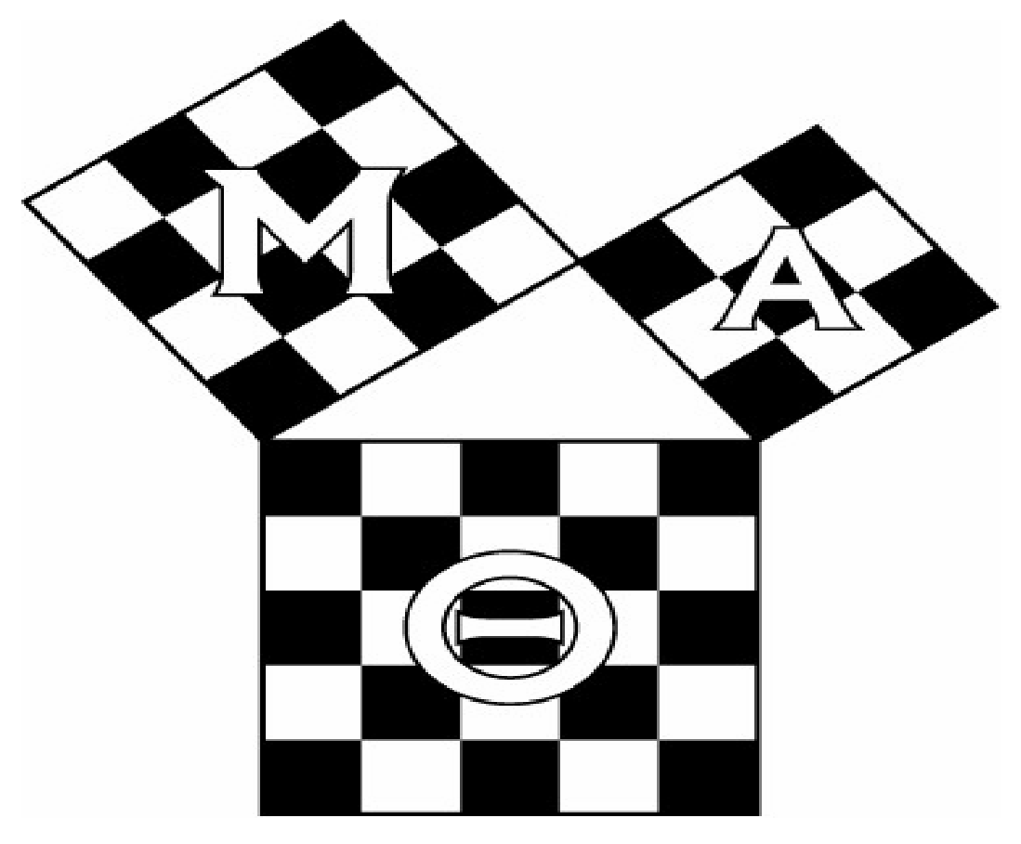

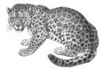 The National High School

Mathematics Honor Society

**Application for Membership**

**Mu Alpha Theta is the National High School Mathematics Honor Society** co-sponsored by the National Council of Teachers of Mathematics and the Mathematical Association of America. We have over 93,300 student members in more than 1,950 schools. We are dedicated to inspiring keen interest in mathematics, developing strong scholarship in the subject, and promoting the enjoyment of mathematics in high school students. The JMHS Co-Advisors are Ms. Kathleen Bunce, Mrs. Maria Gkionis, and Miss. Trisha Seiler.

**If you would like to apply for Membership in Jackson Memorial High School’s chapter of Mu Alpha Theta**, please indicate that by completing BOTH sides of the Mu Alpha Theta Application for Membership. Incomplete applications may not be accepted.

High school students in grades 10 through 12, who have completed Honors Algebra Two, and in addition have completed or are enrolled in an AP math course, are eligible for full membership provided their mathematical work was done with distinction (at least an 85 average). It is an honor to be selected for membership in this organization which has chapters across the United States and in some foreign countries.

**Please return the completed form and $25.00 (checks payable to JMHS) to Ms. Bunce Room 145 (or to her box) by December 1, 2021. Be sure to get completed application and dues in by the due date! If your application is not approved, dues will be returned. You will be notified of your acceptance by letter, along with the time of the next meeting, and the Induction Ceremony.**

Please give your **Legal Name** (As it will appear on your national certificate)

First Name: _________________________ Middle Name: _________________________ Last Name: _____________________________________

Nick Name (if applicable): __________________________________________________________________________________________________

Graduation Year: _________________________ Adult T-Shirt Size: _____________ Home/ Parent Phone Number: __________________________

Mailing Address: ________________________________________________________________________________________________________

City: __________________________________________________ State: ________________ Zip: ____________________________

Student Email Address*: ______________________________________________________ Student Phone Number*: _______________________

Parent Email Address*: ____________________________________________________________________________________________________

*Please provide at least one email address; email will be the primary method of communicating information about upcoming events, and providing reminders of scheduled meetings. Student phone numbers are used only in rare instances. (ex: being absent from a contest you signed up to compete in)

Please read the statements below and provide your signature if they are true for you.

* I have completed Honors Algebra Two with distinction* and would like to apply for full membership in Mu Alpha Theta Mathematics National Honor Society.
* I would like to be an active member supporting the organization’s activities such as monthly meetings, Induction Ceremony, and participating in math-related activities such as fundraising, attending math programs, and/ or participating in math contests.
* I understand that local dues are $25.00 for the first year, and $25 each year afterwards. Fees must be paid with application.#

____________________________________________ __________________________________________________ ________________

Student’s Signature Parent’s Signature Date

Parents’ Names: __________________________________________________________________________________________________________

* Your Pre-AP math average must be a 85 or higher.

* You must earn no lower than an 85 in all Honors Mathematics Course.

# Please let Ms. Bunce know if you feel the dues will be a hardship for you.

Jackson Memorial High School

**Mu Alpha Theta**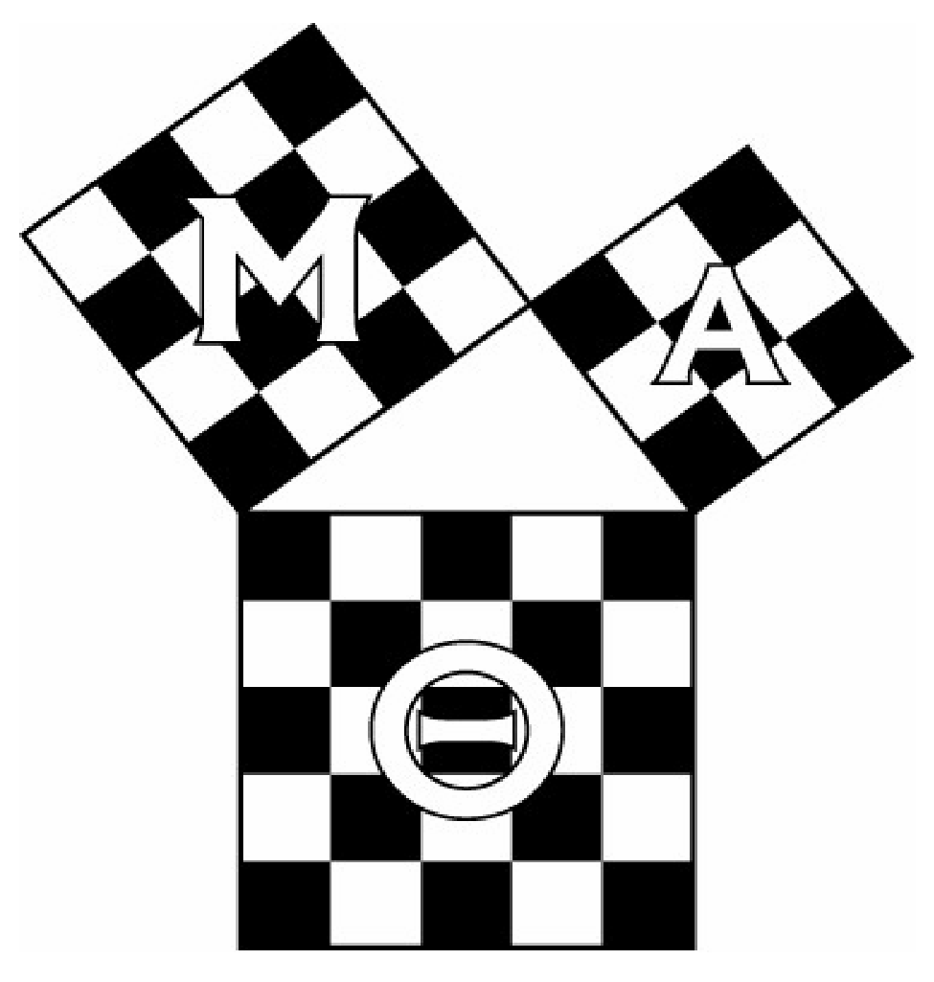



The National High School

Mathematics Honor Society

Math Courses Transcript (Confidential)

Name: ______________________________________________________________________________________________________

Graduation Year: _____ Current Math Course(s): _________________________Period(s): ______ Student I.D. Number: __________

Current Math Teacher(s): _________________________________________________________ Room(s): _____________________

It is the student’s duty to retrieve the accurate transcript information requested from school records, registrar’s office, or school personnel.

|  |  |  |  |  |
| --- | --- | --- | --- | --- |
| School Year  (Such as 12-13) | Grade Level  (Such as 9th) | Math Course  (Honors Algebra Two) | Number Grade Guidance Counselor Signature | |
|  |  |
|  |  |  |  |  |
|  |  |  |  |  |
|  |  |  |  |  |
|  |  |  |  |  |
|  |  |  |  |  |
|  |  |  |  |  |
|  |  |  |  |  |
|  |  |  |  |  |

High School Level Math Courses Average: ________________

The above is a complete and accurate record of my high school math courses (including any I took in middle school which count as high school credit). I understand that inaccuracies on this record will be cause for my forfeiting membership in Mu Alpha Theta National Mathematics Honor Society.

__________________________________ __________________________________ __________________

Student’s Signature Parent’s Signature Date